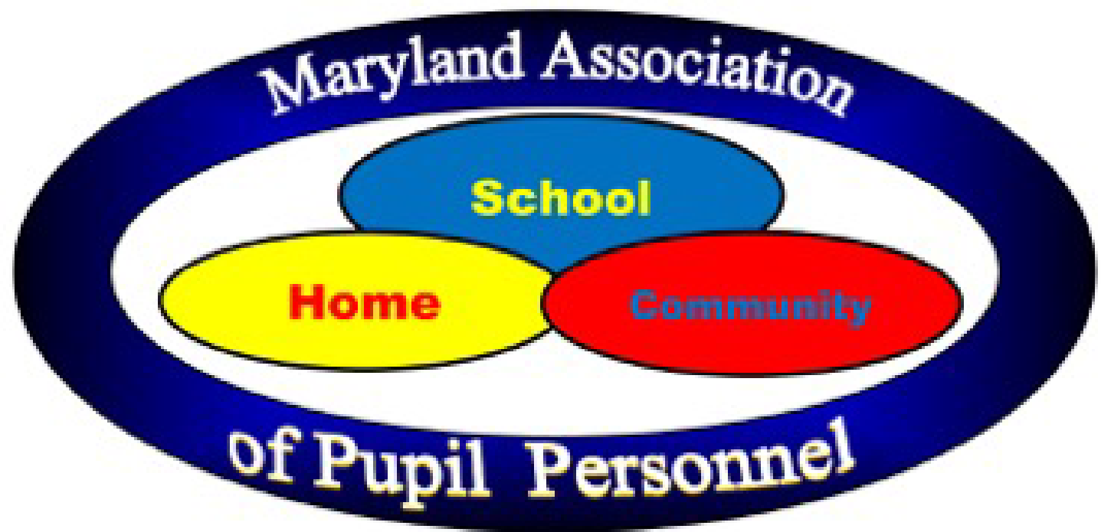

MAPP Service Scholarship Application
2026

Please type or print clearly:

Student Information

Full Name
Last First Middle

Address
Number and Street

City State Zip

Telephone
Home Cell

Date of Birth

Parent/Guardian Information

Name

Address (if different from above)

Telephone
Day Evening

List Sibling Information

Names Age Grade

High School Information

School

Maryland County _______________________________________________________________

Address

Telephone Number

Counselor’s Name

List organizations/activities in which you are currently involved.

School Organizations/Activities

Community Organizations/Activities

Other

If you work, please identify where you work and your responsibilities at your place of employment

Please list all schools (colleges, universities and/or technical schools) you have applied to and identify which schools have sent you a letter of acceptance.

School Letter of Acceptance?

Have you been offered other scholarships or grants?

If yes, please list each:

What is your expected major or program focus?

Essay

On a separate sheet of paper, write an essay on the topic, “My Gift of Service”. Your essay should address your community service activities (including those on the state or national level), services and activities that you have organized or participated in to support others or your efforts within your community, religious organizations, and/or school, etc. Your essay will be evaluated on the type and level of service, language mechanics, coherence, unity, clarity of expression and appearance.

YOUR ESSAY MUST BE ONE TYPED PAGE.

In a sealed envelope, please provide two letters of reference. The Pupil Personnel Worker assigned to your high school must write one letter. A teacher, counselor, minister, employer or any responsible adult other than a relative can write the other letter.

Please be advised that names and pictures of recipients of the MAPP scholarship may be used in future publications/communications (PPW directory, local newspapers, BOE presentations, MAPP conferences etc.). Your signature below indicates your acknowledgement and approval of this.

The following signatures are required for application consideration:

Submitted By:

________________________________________
APPLICANT

________________________________________
PARENT / GUARDIAN

________________________________________
PUPIL PERSONNEL WORKER

By signing above, you are confirming that this student is graduating in 2026.

COMPLETE APPLICATION MUST BE POSTMARKED BY
April 17, 2026.

Date received by local Screening Committee

Date received by MAPP Scholarship Committee

Submit Applications to:

Maryland Association of Pupil Personnel
P.O. Box 753
Arnold MD 21012

OR

themappassociation@gmail.com

